Possible At Home Daily Schedule
 | 8:00am | Wake up, Bathroom and Breakfast
 | 8:30am | Get Dressed, Make Bed
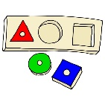 | 9:00am | Morning Activity  (books, puzzle, playtime)
 | 9:30am | Good Morning Circle & Who’s at Home  (family meeting, review daily events,  who is at home today?)
 | 9:45am | Motor Skills  Writing Practice, then big moves like jumping, bear crawling, etc.
 | 10:00am | Circle Time  Pick songs for Calendar, Weather, Shape
 | 10:20am | Structured Play  Pick one activity for 10 minutes, set a timer
 | 10:30am | Bathroom break then Snack time  Practice manners and requesting
 | 10:45am | Themed Song and Book of the Week
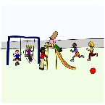 | 11:15am | Recess  free play indoors or outdoors if possible
 | 11:45am | Bathroom and Lunch
 | 12:15pm | Literacy TV Teacher/youtube letter video  Letter scavenger hunt at home

